Appendix B. Parameter Screen Layouts

Maestro:

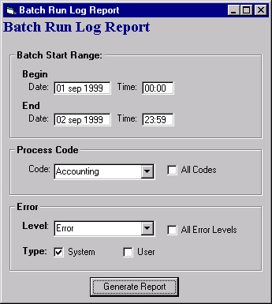
Batch Run Log Report

Maestro Reservation Error Report
